1.

Xml code:

<?xml version="1.0" encoding="utf-8"?>

<androidx.constraintlayout.widget.ConstraintLayout xmlns:android="http://schemas.android.com/apk/res/android"

xmlns:app="http://schemas.android.com/apk/res-auto"

xmlns:tools="http://schemas.android.com/tools"

android:layout_width="match_parent"

android:layout_height="match_parent"

tools:context=".MainActivity">

<TextView

android:layout_width="wrap_content"

android:layout_height="wrap_content"

android:text="Mobile Application Development"

app:layout_constraintBottom_toBottomOf="parent"

app:layout_constraintLeft_toLeftOf="parent"

app:layout_constraintRight_toRightOf="parent"

app:layout_constraintTop_toTopOf="parent" />

</androidx.constraintlayout.widget.ConstraintLayout>

Java code:

package com.example.login;

import androidx.appcompat.app.AppCompatActivity;

import android.os.Bundle;

import android.widget.Toast;

public class MainActivity extends AppCompatActivity {

@Override

protected void onCreate(Bundle savedInstanceState) {

super.onCreate(savedInstanceState);

setContentView(R.layout.*activity_main*);

Toast.*makeText*(this, "welcome to the app", Toast.*LENGTH_SHORT*).show();

}

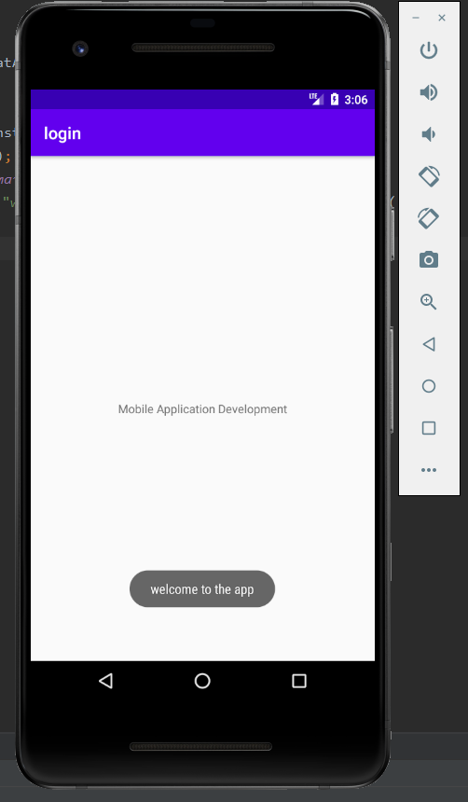

2.

3.

4.

Xml code:

<?xml version="1.0" encoding="utf-8"?>

<androidx.constraintlayout.widget.ConstraintLayout xmlns:android="http://schemas.android.com/apk/res/android"

xmlns:app="http://schemas.android.com/apk/res-auto"

xmlns:tools="http://schemas.android.com/tools"

android:layout_width="match_parent"

android:layout_height="match_parent"

tools:context=".MainActivity">

<TextView

android:id="@+id/textView2"

android:layout_width="wrap_content"

android:layout_height="wrap_content"

android:text="Mobile Application Development"

app:layout_constraintBottom_toBottomOf="parent"

app:layout_constraintLeft_toLeftOf="parent"

app:layout_constraintRight_toRightOf="parent"

app:layout_constraintTop_toTopOf="parent" />

<TextView

android:id="@+id/textView"

android:layout_width="wrap_content"

android:layout_height="wrap_content"

android:text="Login id"

app:layout_constraintBottom_toBottomOf="parent"

app:layout_constraintEnd_toEndOf="parent"

app:layout_constraintHorizontal_bias="0.184"

app:layout_constraintStart_toStartOf="parent"

app:layout_constraintTop_toTopOf="parent"

app:layout_constraintVertical_bias="0.139" />

<TextView

android:id="@+id/textView3"

android:layout_width="wrap_content"

android:layout_height="wrap_content"

android:text="Password"

app:layout_constraintBottom_toBottomOf="parent"

app:layout_constraintEnd_toEndOf="parent"

app:layout_constraintHorizontal_bias="0.184"

app:layout_constraintStart_toStartOf="parent"

app:layout_constraintTop_toTopOf="parent"

app:layout_constraintVertical_bias="0.283" />

<EditText

android:id="@+id/id"

android:layout_width="wrap_content"

android:layout_height="wrap_content"

android:ems="10"

android:inputType="textPersonName"

app:layout_constraintBottom_toBottomOf="parent"

app:layout_constraintEnd_toEndOf="parent"

app:layout_constraintHorizontal_bias="0.825"

app:layout_constraintStart_toStartOf="parent"

app:layout_constraintTop_toTopOf="parent"

app:layout_constraintVertical_bias="0.106" />

<EditText

android:id="@+id/pass"

android:layout_width="wrap_content"

android:layout_height="wrap_content"

android:ems="10"

android:inputType="numberPassword"

app:layout_constraintBottom_toBottomOf="parent"

app:layout_constraintEnd_toEndOf="parent"

app:layout_constraintHorizontal_bias="0.825"

app:layout_constraintStart_toStartOf="parent"

app:layout_constraintTop_toTopOf="parent"

app:layout_constraintVertical_bias="0.256" />

<Button

android:id="@+id/button"

android:layout_width="wrap_content"

android:layout_height="wrap_content"

android:text="login"

app:layout_constraintBottom_toBottomOf="parent"

app:layout_constraintEnd_toEndOf="parent"

app:layout_constraintHorizontal_bias="0.498"

app:layout_constraintStart_toStartOf="parent"

app:layout_constraintTop_toTopOf="parent"

app:layout_constraintVertical_bias="0.42" />

</androidx.constraintlayout.widget.ConstraintLayout>

Java Code:

package com.example.login;

import androidx.appcompat.app.AppCompatActivity;

import android.os.Bundle;

import android.view.View;

import android.widget.Button;

import android.widget.EditText;

import android.widget.Toast;

public class MainActivity extends AppCompatActivity {

@Override

protected void onCreate(Bundle savedInstanceState) {

super.onCreate(savedInstanceState);

setContentView(R.layout.*activity_main*);

Toast.*makeText*(this, "welcome to the app", Toast.*LENGTH_SHORT*).show();

final EditText t1=findViewById(R.id.*id*);

final EditText t2=findViewById(R.id.*pass*);

Button b=findViewById(R.id.*button*);

b.setOnClickListener(new View.OnClickListener() {

@Override

public void onClick(View view) {

if(t1.getText().toString().equals("siddu") && t2.getText().toString().equals("1234")){

Toast.*makeText*(getApplicationContext(),"login successful",Toast.*LENGTH_LONG*).show();

}else{

Toast.*makeText*(getApplicationContext(),"login failed",Toast.*LENGTH_LONG*).show();

}

}

});

}

}

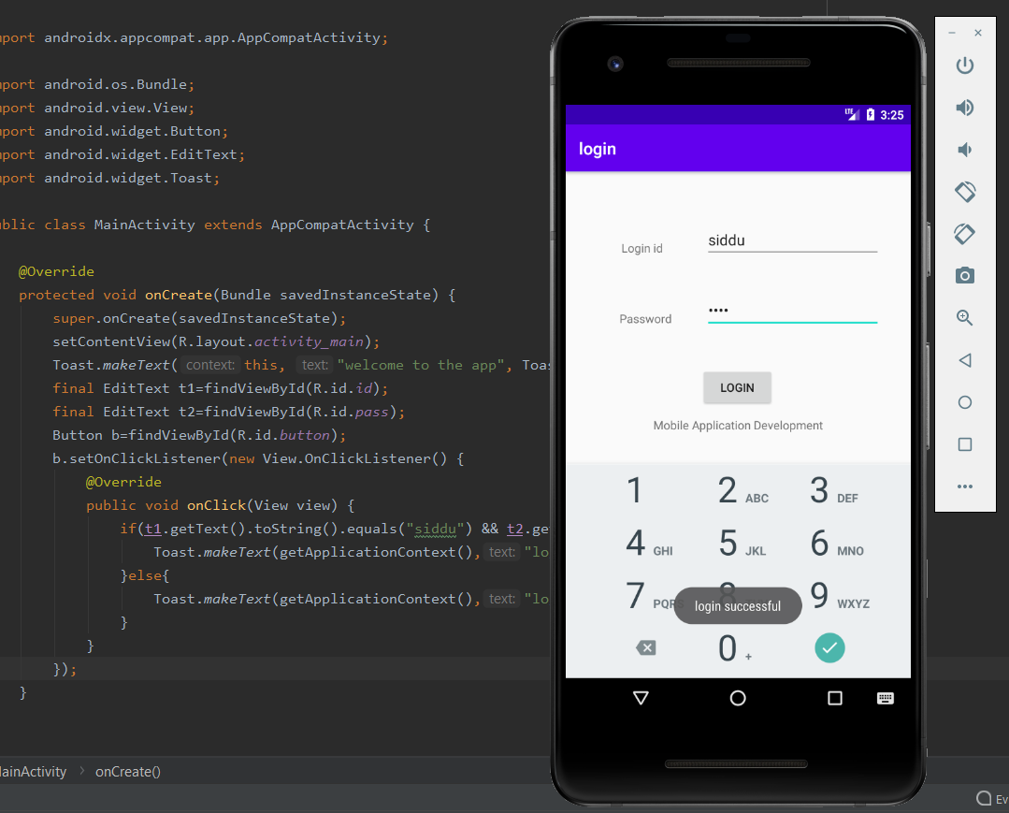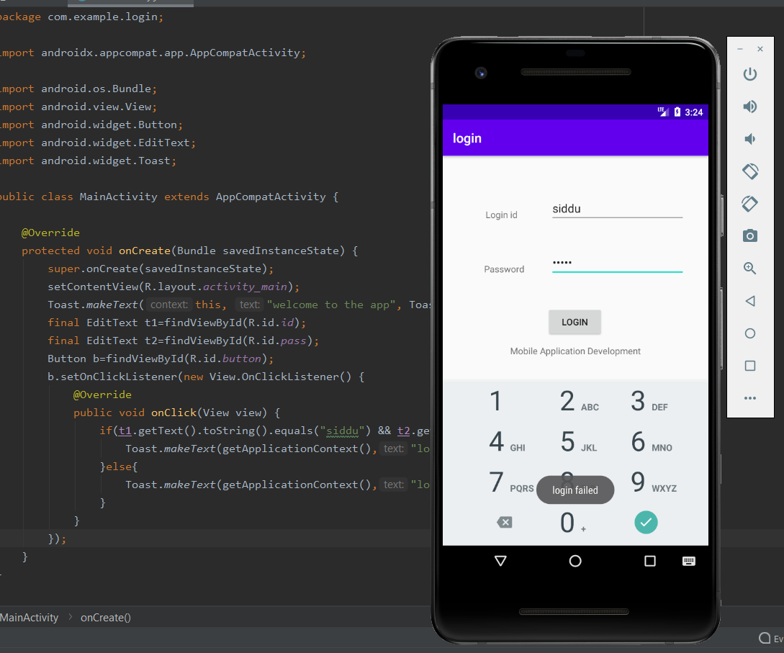

5.

Xml code:

<?xml version="1.0" encoding="utf-8"?>

<androidx.constraintlayout.widget.ConstraintLayout xmlns:android="http://schemas.android.com/apk/res/android"

xmlns:app="http://schemas.android.com/apk/res-auto"

xmlns:tools="http://schemas.android.com/tools"

android:layout_width="match_parent"

android:layout_height="match_parent"

tools:context=".MainActivity">

<TextView

android:id="@+id/textView4"

android:layout_width="wrap_content"

android:layout_height="wrap_content"

android:layout_marginStart="43dp"

android:layout_marginTop="75dp"

android:layout_marginEnd="310dp"

android:layout_marginBottom="637dp"

android:text="1st number"

app:layout_constraintBottom_toBottomOf="parent"

app:layout_constraintEnd_toEndOf="parent"

app:layout_constraintStart_toStartOf="parent"

app:layout_constraintTop_toTopOf="parent" />

<TextView

android:id="@+id/textView5"

android:layout_width="wrap_content"

android:layout_height="wrap_content"

android:layout_marginStart="41dp"

android:layout_marginTop="77dp"

android:layout_marginEnd="312dp"

android:layout_marginBottom="400dp"

android:text="2nd number"

app:layout_constraintBottom_toBottomOf="parent"

app:layout_constraintEnd_toEndOf="parent"

app:layout_constraintHorizontal_bias="0.47"

app:layout_constraintStart_toStartOf="parent"

app:layout_constraintTop_toBottomOf="@+id/textView4"

app:layout_constraintVertical_bias="0.382" />

<EditText

android:id="@+id/input"

android:layout_width="wrap_content"

android:layout_height="wrap_content"

android:layout_marginStart="45dp"

android:layout_marginTop="54dp"

android:layout_marginEnd="55dp"

android:layout_marginBottom="632dp"

android:ems="10"

android:inputType="textPersonName"

app:layout_constraintBottom_toBottomOf="parent"

app:layout_constraintEnd_toEndOf="parent"

app:layout_constraintStart_toEndOf="@+id/textView4"

app:layout_constraintTop_toTopOf="parent" />

<EditText

android:id="@+id/input2"

android:layout_width="wrap_content"

android:layout_height="wrap_content"

android:layout_marginEnd="48dp"

android:ems="10"

android:inputType="textPersonName"

app:layout_constraintBottom_toBottomOf="parent"

app:layout_constraintEnd_toEndOf="parent"

app:layout_constraintTop_toTopOf="parent"

app:layout_constraintVertical_bias="0.262" />

<Button

android:id="@+id/add"

android:layout_width="wrap_content"

android:layout_height="wrap_content"

android:text="+"

app:layout_constraintBottom_toBottomOf="parent"

app:layout_constraintEnd_toEndOf="parent"

app:layout_constraintHorizontal_bias="0.405"

app:layout_constraintStart_toStartOf="parent"

app:layout_constraintTop_toTopOf="parent" />

<Button

android:id="@+id/sub"

android:layout_width="wrap_content"

android:layout_height="wrap_content"

android:text="-"

app:layout_constraintBottom_toBottomOf="parent"

app:layout_constraintEnd_toEndOf="parent"

app:layout_constraintHorizontal_bias="0.043"

app:layout_constraintStart_toStartOf="parent"

app:layout_constraintTop_toTopOf="parent" />

<Button

android:id="@+id/mul"

android:layout_width="wrap_content"

android:layout_height="wrap_content"

android:text="*"

app:layout_constraintBottom_toBottomOf="parent"

app:layout_constraintEnd_toEndOf="parent"

app:layout_constraintHorizontal_bias="0.049"

app:layout_constraintStart_toStartOf="parent"

app:layout_constraintTop_toTopOf="parent"

app:layout_constraintVertical_bias="0.655" />

<Button

android:id="@+id/div"

android:layout_width="wrap_content"

android:layout_height="wrap_content"

android:text="/"

app:layout_constraintBottom_toBottomOf="parent"

app:layout_constraintEnd_toEndOf="parent"

app:layout_constraintHorizontal_bias="0.405"

app:layout_constraintStart_toStartOf="parent"

app:layout_constraintTop_toTopOf="parent"

app:layout_constraintVertical_bias="0.655" />

<TextView

android:id="@+id/textView"

android:layout_width="60dp"

android:layout_height="42dp"

android:text="result"

app:layout_constraintBottom_toBottomOf="parent"

app:layout_constraintEnd_toEndOf="parent"

app:layout_constraintHorizontal_bias="0.076"

app:layout_constraintStart_toStartOf="parent"

app:layout_constraintTop_toTopOf="parent"

app:layout_constraintVertical_bias="0.783" />

<EditText

android:id="@+id/result"

android:layout_width="wrap_content"

android:layout_height="wrap_content"

android:ems="10"

android:inputType="textPersonName"

app:layout_constraintBottom_toBottomOf="parent"

app:layout_constraintEnd_toEndOf="parent"

app:layout_constraintHorizontal_bias="0.651"

app:layout_constraintStart_toStartOf="parent"

app:layout_constraintTop_toTopOf="parent"

app:layout_constraintVertical_bias="0.756" />

</androidx.constraintlayout.widget.ConstraintLayout>

Java Code:

package com.example.cse4002;

import androidx.appcompat.app.AppCompatActivity;

import android.os.Bundle;

import android.view.View;

import android.widget.Button;

import android.widget.EditText;

public class MainActivity extends AppCompatActivity {

@Override

protected void onCreate(Bundle savedInstanceState) {

super.onCreate(savedInstanceState);

setContentView(R.layout.*activity_main*);

Button b1=findViewById(R.id.*add*);

Button b2=findViewById(R.id.*sub*);

Button b3=findViewById(R.id.*mul*);

Button b4=findViewById(R.id.*div*);

final EditText t1=findViewById(R.id.*input*);

final EditText t2=findViewById(R.id.*input2*);

final EditText t3=findViewById(R.id.*result*);

b1.setOnClickListener(new View.OnClickListener() {

@Override

public void onClick(View view) {

int x=Integer.*parseInt*(t1.getText().toString());

int y=Integer.*parseInt*(t2.getText().toString());

int z=x+y;

t3.setText(String.*valueOf*(z));

}

});

b2.setOnClickListener(new View.OnClickListener() {

@Override

public void onClick(View view) {

int x=Integer.*parseInt*(t1.getText().toString());

int y=Integer.*parseInt*(t2.getText().toString());

int z=x-y;

t3.setText(String.*valueOf*(z));

}

});

b3.setOnClickListener(new View.OnClickListener() {

@Override

public void onClick(View view) {

int x=Integer.*parseInt*(t1.getText().toString());

int y=Integer.*parseInt*(t2.getText().toString());

int z=x*y;

t3.setText(String.*valueOf*(z));

}

});

b4.setOnClickListener(new View.OnClickListener() {

@Override

public void onClick(View view) {

int x=Integer.*parseInt*(t1.getText().toString());

int y=Integer.*parseInt*(t2.getText().toString());

int z=x/y;

t3.setText(String.*valueOf*(z));

}

});

}

}

